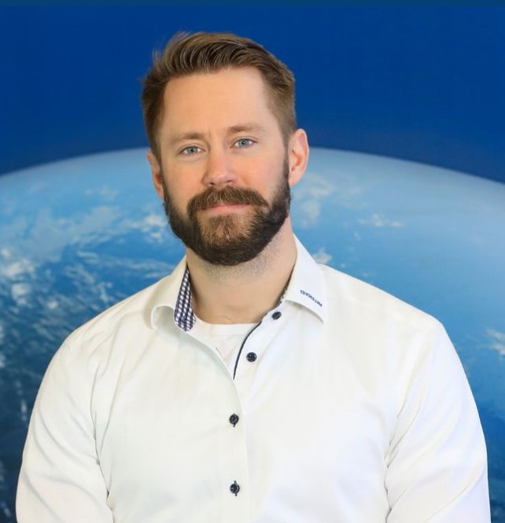

Lukas Larsson
Greater Gothenburg Area | 073-740 97 88 | lukasglarsson88@gmail.com
LinkedIn: https://www.linkedin.com/in/lukas-larsson-062163169
Introduction
Business developer and sales professional with a strong B2B track record in technical solutions, HVAC, and industrial environments. Experienced in driving the full sales cycle, developing profitable service and product offerings, and building long-term customer and partner relationships through hands-on, customer-facing work.

Core Competencies
- B2B sales & full-cycle deal management (technical & solutions)
- Service and solution-oriented sales models
- Customer development & long-term relationship building
- Partner and installer network development
- Profitability responsibility & commercial ownership
- Technical understanding of machinery, installations, and field operations
- On-site customer work, remote and hybrid execution

Professional Experience
MedTech Startup – Co-founder & Business Development
2025–Present
- Leading commercial development and go-to-market strategy for a SaaS solution in a highly regulated technical environment
- Translating complex customer needs into structured offerings and sales material
- Driving early-stage sales processes, customer dialogue, and market entry strategy
Valeryd AB – Project Manager & Technical Sales Specialist
2023–Present
- Responsible for growing sales and product portfolio within technical components
- Developed B2B customer relationships and partner channels with focus on long-term value and profitability
- Conducted market analysis and supported strategic partnerships with key accounts
- Worked closely with internal stakeholders to ensure delivery quality and customer satisfaction

Hercules Grundläggning – Site Manager
2022–2023
- Managed complex, machinery-heavy projects with direct customer responsibility
- Led multidisciplinary teams and coordinated subcontractors and equipment
- Ensured profitability, safety, compliance, and timely delivery in demanding technical environments

Svensk Installationspartner / BHG – Product Manager & Business Developer
2017–2021
- Rolled out the “Installed & Ready” concept nationwide for Bygghemma
- Built and managed installer networks, contracts, and service quality follow-up
- Developed scalable installation services within HVAC, solar, and electrical solutions
- Balanced operational execution, commercial responsibility, and strategic development

Polarpumpen – Technical Sales
2014–2017
- High-volume B2B and B2C sales of heat pumps and solar panel systems
- Managed the full sales cycle: needs analysis, solution design, closing, and aftersales
- Built strong customer relationships through consultative, solution-oriented selling

Swedish Armed Forces – Reconnaissance Marine, Corporal
2012–2014
- Developed leadership, discipline, and problem-solving skills under pressure
- Worked in team-based, mission-critical environments requiring high accountability

Education
Yrgo – Bachelor of Science in Engineering
2020–2022

Languages
- Swedish: Native
- English: Fluent (spoken & written)
- Danish: Working proficiency

Other
- B driver’s license
- Used to frequent travel and on-site customer work
- Strong system literacy and comfort working in digital tools and CRM environments

